FINAL TEST

Part 1: ( 4 ps)
You have a new computer. Write an email to your English friend, Alex.
In your email, you should
- explain why you like the new computer
- invite Alex to come to your house
- suggest what you can do together on the computer.
Write 35 – 45 words.
Dear Alex ,
You know ! I’ve just gotten a new computer – a core i7 HP. It’s fantastically powerful and actually fast. I feel it very convenient. It merely takes this gadget no more than 10 seconds to start up for its user. The popular apps running on it that you and I often used to would respond rapidly to our action, I’ve never had to wait any complex processing even a minute.
I think you would like to experience it on your own with me. Why wouldn’t you come my place this weekend? We would write together our C++ program and then play some game on it.
Bye and see you soon.
Best regards
Minh Duc

Part 2: (6ps)
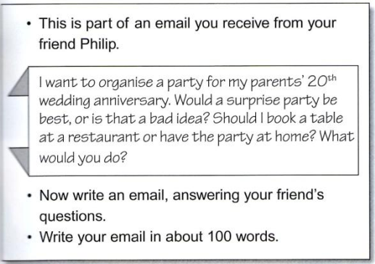

Hi Phillip!
Glad to hear yours again!
You’re so good to remember your parents’ wedding day. They’ll certainly be funny to see everything you’ve planned.
I’m not sure whether a surprise party is the best for everyone. But your idea will absolutely not be bad at all even if your parents aren’t quite amazed. Your love and care for them is more valuable than all things.
How many people will there be at the party? Who else will be invited to? If there is only few members in your family, I think you should cook for them a special dinner in your house. It’ll be warm and lovely rather than a restaurant table.
Be happy with your family.
Sincerely yours.
Minh Duc

